Task No. #07
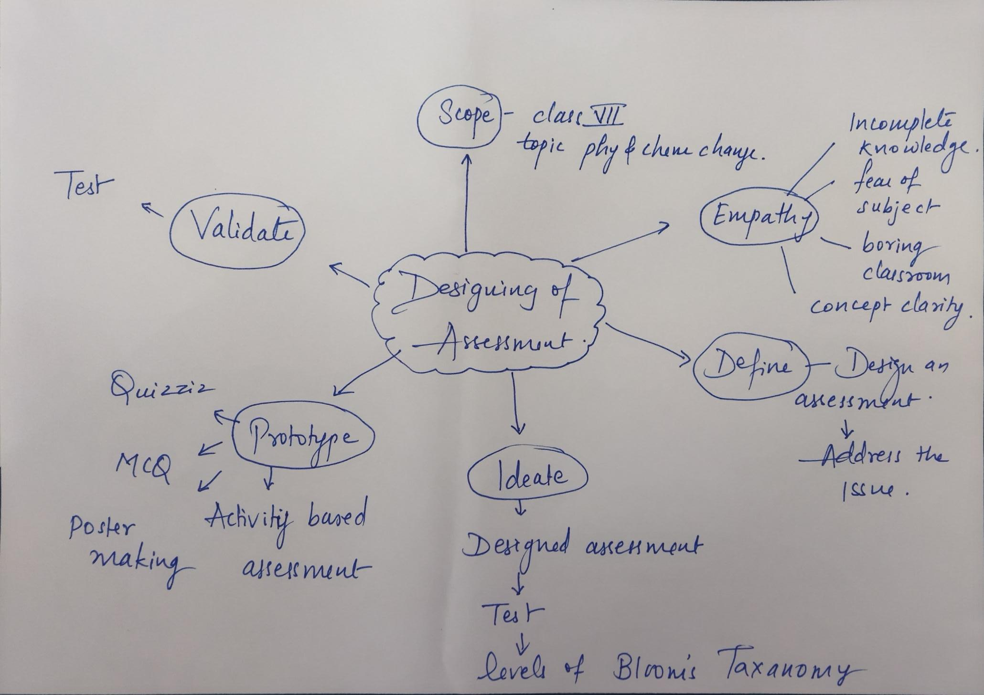
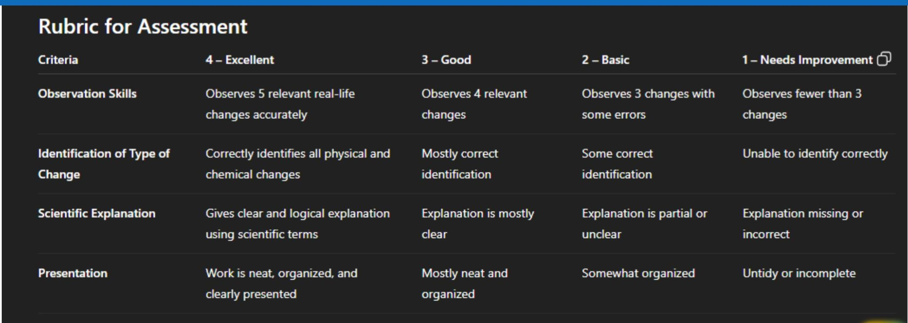
Name : Mr.Bhushan Dhanraj Nikam

